**DATABASE WEEK 2 ASSIGNMENT ANSWERS**

**WEEK 2: ESSENTIAL DATA RETRIEVAL & FILTERING**

**PART 1: Retrieving Data with SELECT**

**1.1 Retrieving All Expenses**

SQL query to retrieve all data points (columns) from the "Expenses" table:

**SELECT \***

**FROM expenses;**

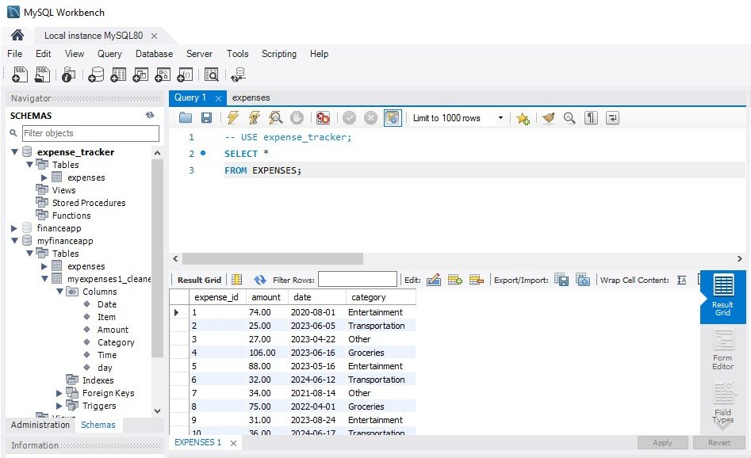

**1.2 Specific Columns**

Query to select date, category, and amount to analyze spending patterns by category and date:

**SELECT date, category, amount**

**FROM expenses;**

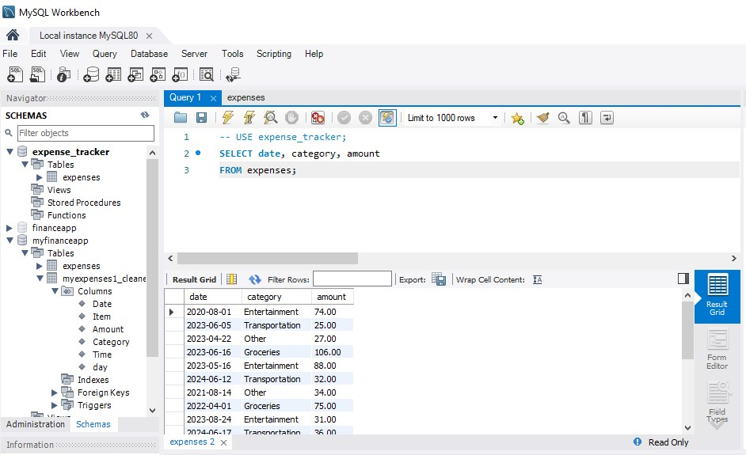

**1.3 Filtering by Date Range:**

A query to retrieve expenses charged between a specific date range:

**SELECT date, category, amount**

**FROM expenses**

**WHERE date BETWEEN ‘2022-01-01’ AND ‘2024-12-15’**

**ORDER BY date;**

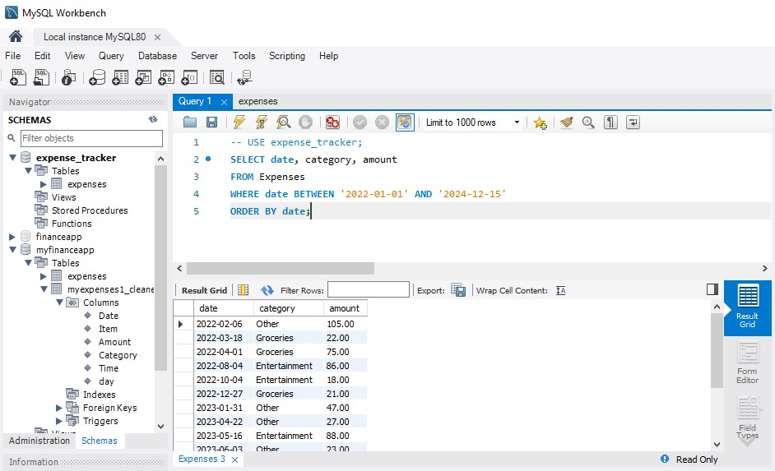

**PART 2: Filtering with WHERE Clause**

**2.1 Filtering by Category**

A query to find all expenses belonging to a specific category (e.g., "Entertainment"):

**SELECT date, category, amount**

**FROM expenses**

**WHERE category=‘Entertainment’;**

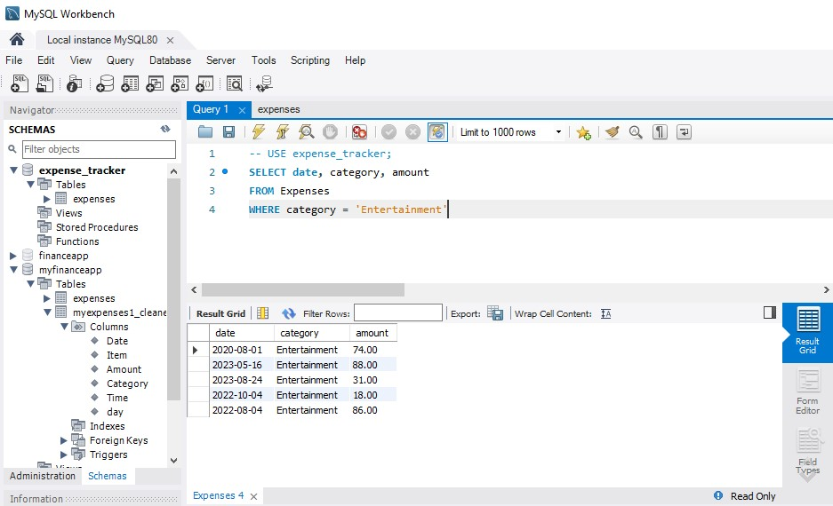

**2.2 Filtering with Comparison Operators**

Finding expenses with an amount greater than a certain value (e.g., $50):

**SELECT date, category, amount**

**FROM expenses**

**WHERE amount>50;**

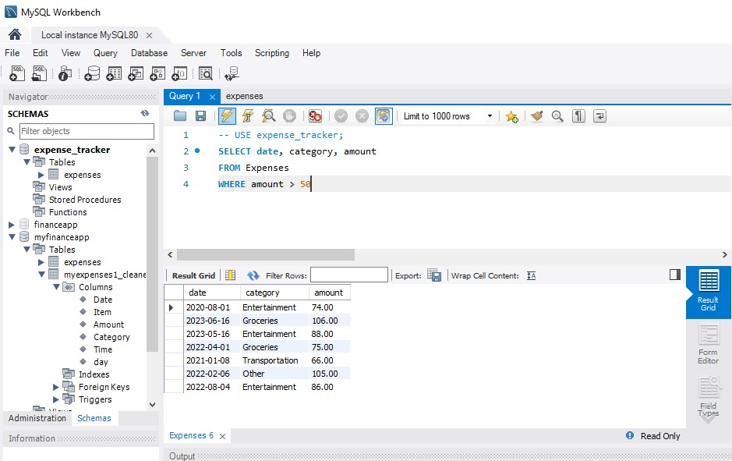

**2.3 Combining Filters (AND)**

A query to find expenses that meet multiple criteria. For example, you might search for expenses greater than $75 AND belonging to the "Groceries" category:

**SELECT date, category, amount**

**FROM expenses**

**WHERE amount>75 AND category=‘Groceries’;**

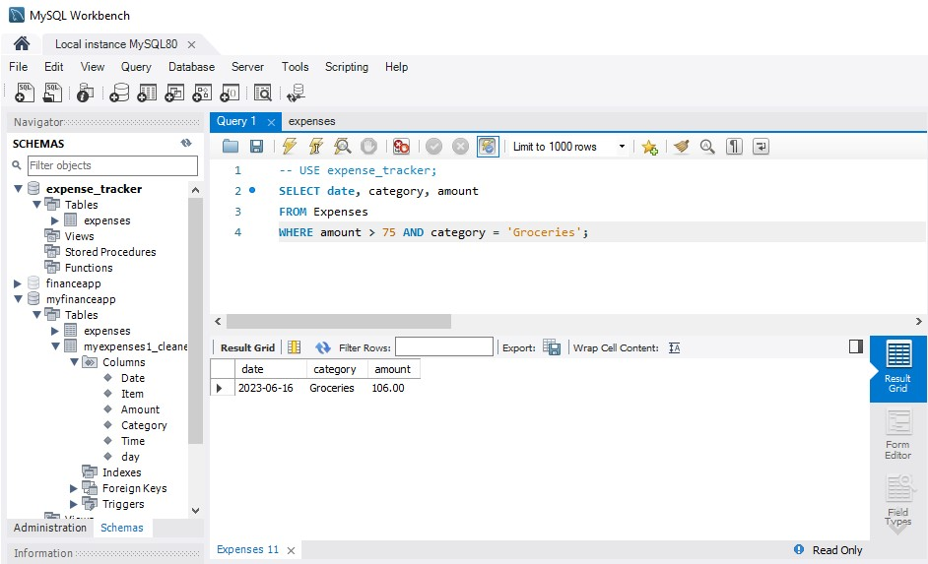

**2.4 Combining Filters (OR)**

A query to find expenses belonging to one category or another (e.g., "Transportation" OR "Groceries").

**SELECT date, category, amount**

**FROM expenses**

**WHERE category=‘Transportation’ OR category=‘Groceries’;**

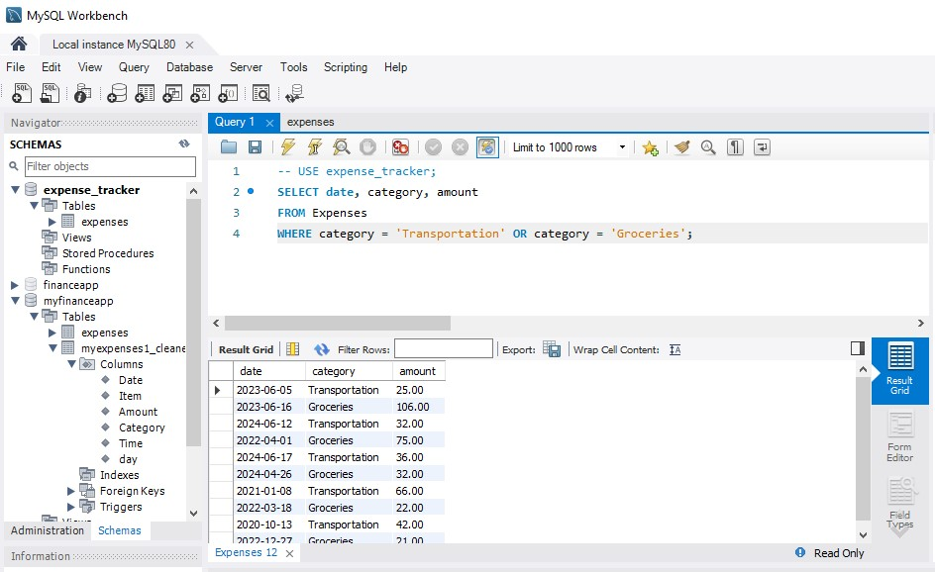

**2.5 Filtering with NOT**

A query to display expenses unrelated to a specific category (e.g., "Rent"):

**SELECT date, category, amount**

**FROM expenses**

**WHERE category !=‘Rent’;**

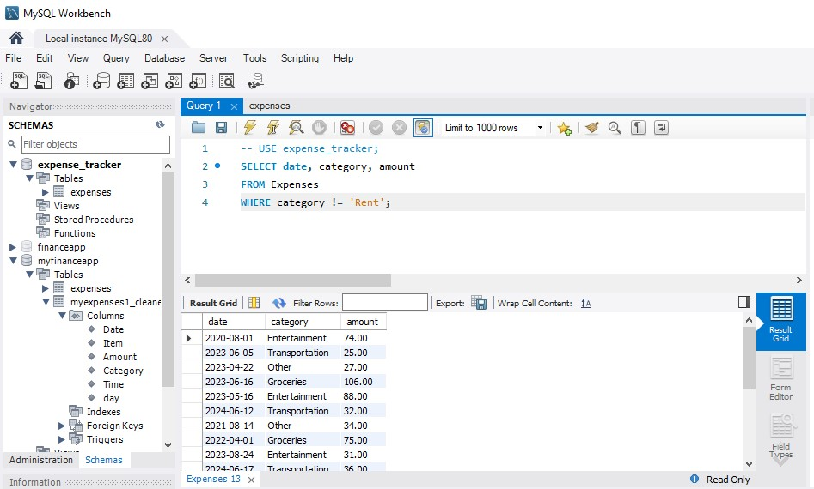

**Part 3: Sorting Retrieved Data**

**3.1 Sorting by Amount**

A query to display all expenses sorted by amount in a specific order (e.g., descending order for highest to lowest spending).

**SELECT date, category, amount**

**FROM expenses**

**ORDER BY amount DESC;**

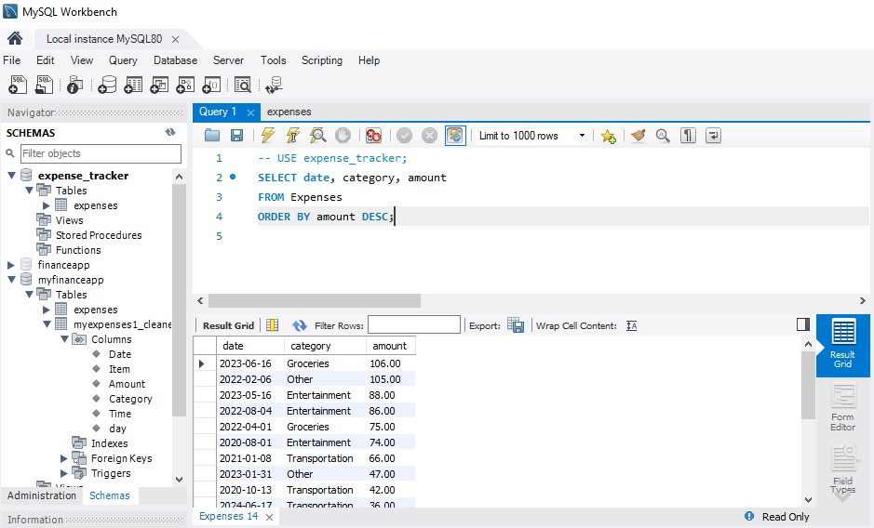

**3.2 Sorting by Date and Category**

A query to sort expenses based on multiple columns. For example, sorting first by date (descending order) and then by category (ascending order) to see recent spending trends by category:

**SELECT date, category, amount**

**FROM expenses**

**ORDER BY date DESC, category;**

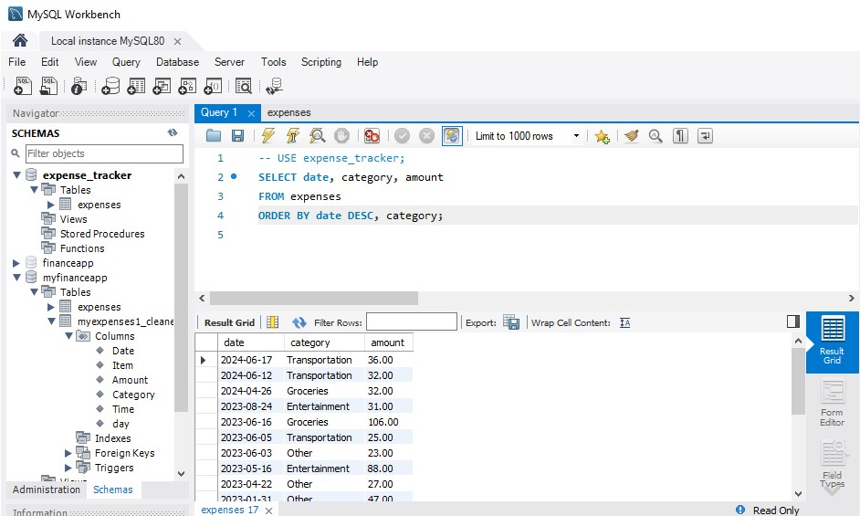

**Part 4: Database Upgrade**

**4.1 Writing SQL Commands to create a table named “Income”**

Here is the SQL Command:

**CREATE TABLE Income (**

**income_id INT AUTO_INCREMENT PRIMARY KEY,**

**amount DECIMAL(10,2) NOT NULL,**

**date DATE NOT NULL,**

**source VARCHAR(50) NOT NULL**

**);**

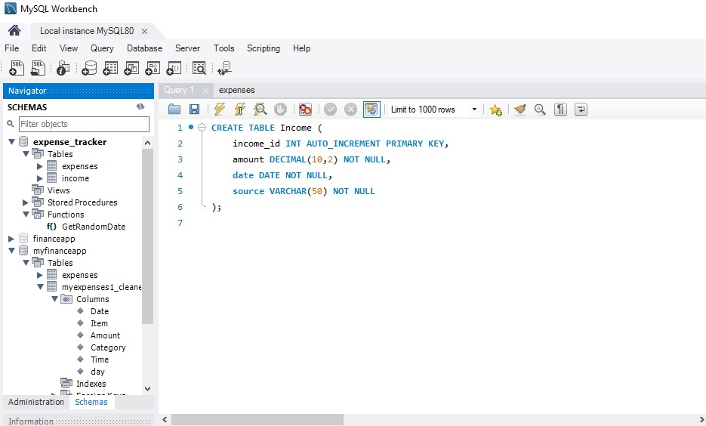

**4.2 Using ALTER TABLE to add a new column named "category" of type VARCHAR(50).**

Here is the SQL Command that I will use to add “category” column to the Income table:

**ALTER TABLE Income**

**ADD COLUMN category VARCHAR(50);**

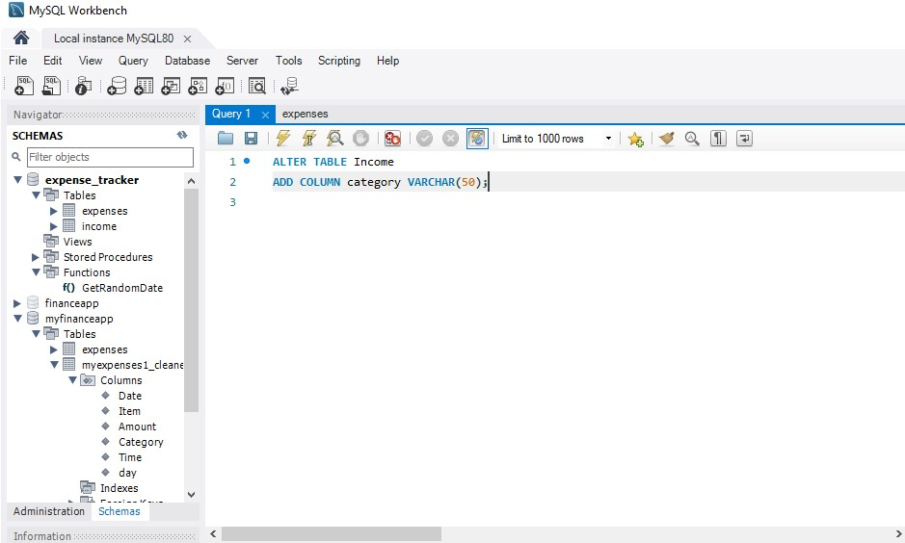

**4.3 Using ALTER TABLE again to remove the "source" column from the "Income" table.**

Here is the SQL Command that I will use to remove “source” column from the Income table:

**ALTER TABLE Income**

**DROP COLUMN source;**

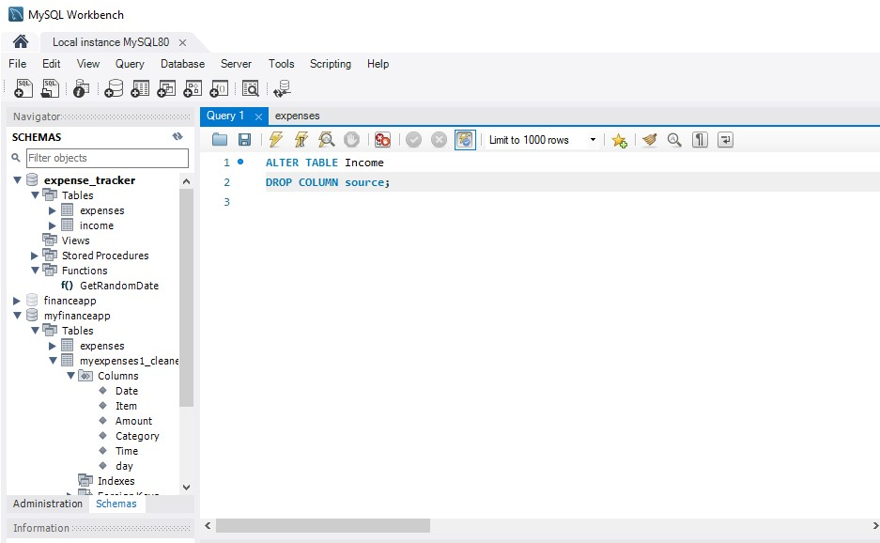

**4.4 How to Use DROP TABLE to permanently remove “Income” table from database.**

Here is the SQL Command that I will use to permanently remove “Income” table from the database:

**DROP TABLE Income;**

